 | 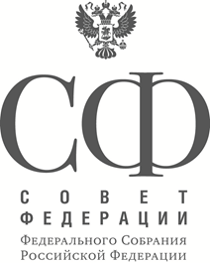 | Analytical Report Summary  for the 7th Nevsky International Ecological Congress  Strategies for Environmental Safety: Tools for Implementation
The full version of the report is available on the official website of the Council of the Federation in the section Activities/ Publications and Analytical Materials.
The 7th Nevsky International Environmental Congress will discuss pressing matters of environmental security, including economic aspects of law enforcement in handling production and consumer waste; soil resource management techniques; water use and quality; ecotourism, environmental security during natural resource exploration and mining sites; and current environmental security mechanisms. The report below expounds on these and other aspects of environmental safety.
Section I. Government policies on environmental protection
The section contains information on the progress in implementing the recommendations set out in the final resolution of the 6th Nevsky International Ecological Congress. It highlights the large-scale efforts of the Interparliamentary Assembly of the CIS
countries in enacting model laws and regulations that set up the framework for a concerted environmental policy across the CIS. The section lists a number of events held throughout the CIS with a view to promoting and disseminating an environmental culture. It also reports on the activities of the federal legislative and executive authorities of the Russian Federation in compliance with the resolutions of the 6th Nevsky International Ecological Congress. | 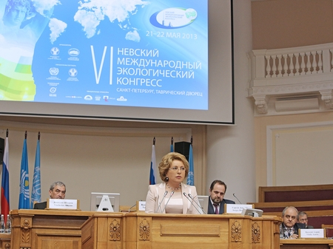

The section examines amendments to the environmental laws of the Russian Federation passed in the last two years. Specifically, it notes adoption of regulations on assessing environmental impact and implementation of the best available techniques principle; water management and air quality controls; and mitigation of the negative consequences of climate change. A number of amendments are associated with laws regulating designated conservation areas. It also points out the considerable efforts made to comply with environmental standards during the preparations for and holding of the Sochi 2014 Winter Olympics.
The section contains information on the activities of the Ministry of Natural Resources and Environment of Russia linked to environmental security in 2014. Notably, the Ministry’s major emphasis was on developing regulations in compliance with Federal Law No. 219-FZ “On Amendments to the Federal Law ‘On Environmental Protection’ and Certain Other Laws of the Russian Federation” dated 21 July 2014. Improving legislative controls on waste management activities is described as another major area of focus in environmental activities.

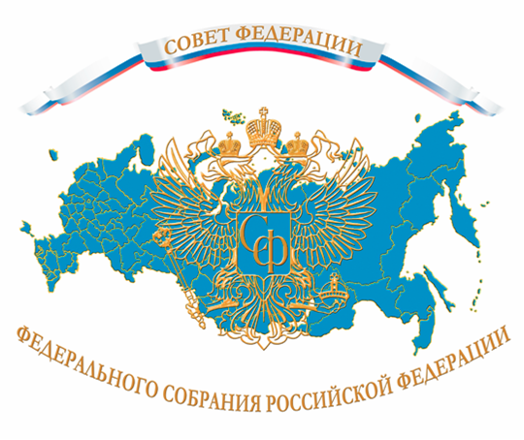 | Examination of regional experience in ensuring environmental safety based on the information submitted to the Council of the Federation by constituent entities of the Russian Federation is given a special place in the report. The following issues have been listed as the main environmental problems across the regions: production and consumer waste management, problems of the water resource utilisation system, issues linked to forestry and designated conservation area management, air pollution
issues and reduction of previously accumulated environmental damage.
The documents supplied by constituent entities of the Russian Federation set forth specific programmes and projects under way in their relevant areas, as well as further proposals for amending and improving the federal environmental legislation.
Section II. Modern threats to environmental security and methods for mitigating them
This section profiles a number of current threats to environmental security and ways proposed by the Russian scientific community for tackling them. Specifically, it highlights the following:
- ways to resolve such environmental issue as pollution with eco-toxicants;
- methods for reducing negative processes resulting in agricultural exhaustion and farm lands being taken out of productive use;
- protection of various types of black soil and provision of a legislative framework for authorities of all levels in land use management;
- introduction of alternative fuels to reduce environmental impact and bring down air pollution levels;
- use of small drones for environmental safety management purposes.
The section also describes international best practices in waste management – an issue at the top of agenda for most constituent entities of Russia.
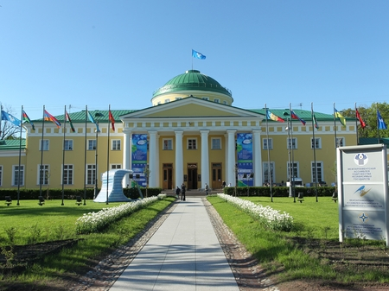
St Petersburg, Tavrichesky (Tauride) Palace (47 Shpalernaya Street)

